**Lab 3 assignment**

Name: Yerraballi Suresh Kumar Reddy

USN:19MCAR0080

4MCA General

Python Programming Lab

Date: 29/01/21

**1. What possible values can a Boolean expression have?**

True or False

**Example:**

a=30

b=45

print(a==b)

print('\n')

print(a!=b)

**Output:**

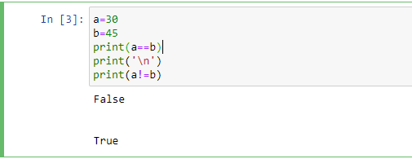

**2. Where does the term Boolean originate?**

The term [Boolean](https://en.wikipedia.org/wiki/Boolean_algebra_%28structure%29#History)was derived from George Boole's name who was the father of this discipline in mathematics.

**3. What is an integer equivalent to True in Python?**

Boolean integer which is 1 for true

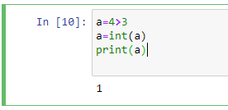

**4. What is the integer equivalent to False in Python?**

Boolean integer which is 0 for false

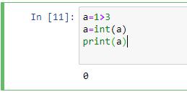

**5. Is the value -16 interpreted as True or False?**

No I guess

**6. Given the following definitions:**

x, y, z = 3, 5, 7

evaluate the following Boolean expressions:

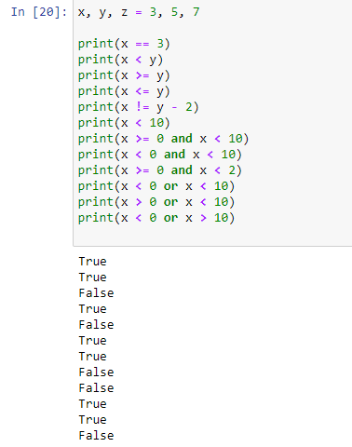

**7. Given the following definitions:**

x, y = 3, 5

b1, b2, b3, b4 = True, False, x == 3, y < 3

evaluate the following Boolean expressions:

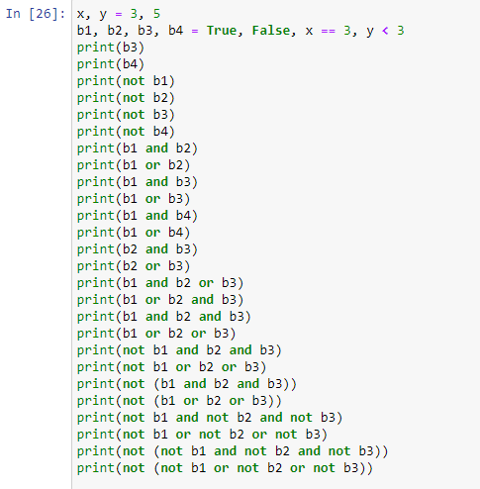

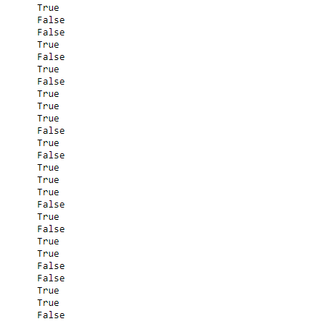

**8. Express the following Boolean expressions in simpler form; that is, use fewer operators or fewer**

**symbols. x is an integer.**

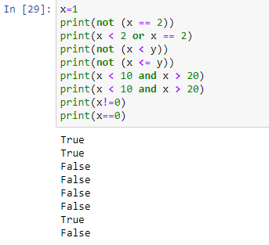

**19. Write a Python program that requests five integer values from the user. It then prints one of two things:**

**if any of the values entered are duplicates, it prints "DUPLICATES"; otherwise, it prints "ALL UNIQUE".**

